ALGORITHM DESIGN
LLM generated algorithm design
- LLM used: Claude
- Model version: Claude 3.5 Sonnet
- Date accessed: 31st January 2026
- Prompt used:
“Generate an initial flowchart representation of an algorithm design for the following task:
Task 4: Traffic Light…
The purpose of this program is to navigate the SwiftBot using colour codes detected by its camera. The program should process images of traffic lights displaying three colours: red, green, and blue. The red and green traffic lights follow standard traffic conventions: red signals the SwiftBot to stop, while green indicates it should proceed forward. The blue light represents a special scenario where the SwiftBot must temporarily yield its path - similar to how vehicles give way to emergency vehicles in real-world situations. While actual lights can be used, coloured images may be substituted. The SwiftBot should respond to traffic lights when they are within 20 cm of its position. The program should process the photo taken by the SwiftBot’s camera to determine the colour of the traffic light. One recommended approach is to convert the image into a pixel matrix and use the RGB values of each pixel to compute an average colour value. This average colour value can then be used to determine the traffic light colour. To start the program, the user must press button ‘A’ on the SwiftBot. This should make the SwiftBot, first, turn the underlights to yellow, and, then, start moving forward at a low speed (initial speed) until it encounters the traffic light. The program should display the initial speed to the user. The SwiftBot should respond to the traffic light when it is 30 cm (or less) ahead of the robot. Your program should check for traffic lights at regular intervals while the SwiftBot is moving. Choose an appropriate time interval, according to your initial speed, to ensure reliable detection. When a traffic light is detected, the program should display both its colour and its distance from the SwiftBot. Upon detecting a green light, the underlights should be set to green and the SwiftBot should pass the traffic light within 2 seconds. After passing the traffic light, the SwiftBot should stop for a second, set the underlights to yellow, and then the robot should move forward in its initial speed until it detects the next traffic light. The appropriate forward speed can be calculated through experimentation with your SwiftBot using simple mathematics (refer Calibrate Your SwiftBot worksheet for more guidance). Upon detecting a red light, the SwiftBot should set its underlights to red and the SwiftBot should come to a stop at the traffic light. After a second, the SwiftBot should start moving forward at its initial speed until it detects the next traffic light. Upon detecting a blue light, the SwiftBot should stop for a second, blink the underlights in blue and then, should turn left by 90 degrees. The robot should then move forward at a low speed for 1 second and stop. After a second, the SwiftBot should retrace its movement and move back to the original path. Then the robot should move forward at its initial speed until it detects the next traffic light. The program terminates when the user presses the 'X' button on the SwiftBot. After every three lights detected (i.e., after the 3rd light, 6th light, 9th light, and so on) and after completing the navigation for the third light, the user should be prompted to either terminate the program or continue. Before terminating, it should ask the user whether to display the execution log. If the user presses button 'Y', the program should display the following information: the number of times the SwiftBot encountered traffic lights, the most frequent traffic light colour the SwiftBot encountered, the number of times the most frequent traffic light was detected, and the total duration of execution. If the user does not want to view the log, the user should press button ‘X’ again. In either case, the program should write the log information to a text file before terminating and display the location of the log file to the user before terminating. This program should be implemented using a command-line user interface (input and output printed in the command prompt). Your program should make appropriate error checks and exception handling in order to ensure that the input values are within the valid range specified in the task description. Invalid input should be rejected, and informative error messages should be displayed, prompting the user for new input. The software should be designed to enhance user experience and ease of use.”

This is what Claude generated as an initial flowchart representation for this task:
1.
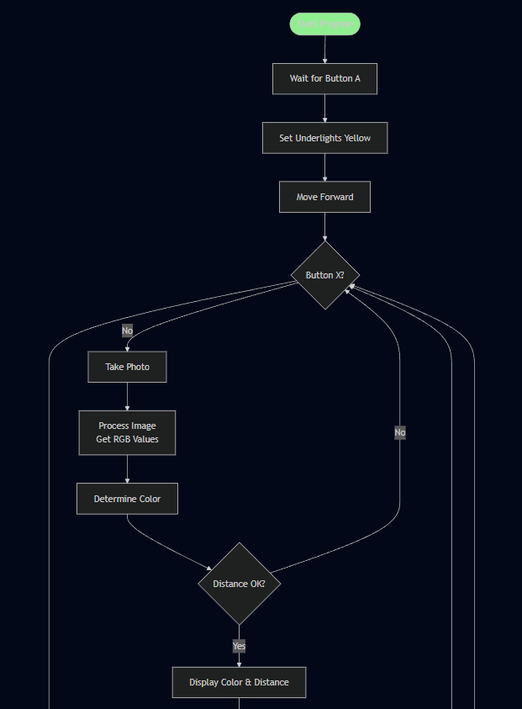
“Traffic Light Navigation - Initial Algorithm Flowchart
I'll create a comprehensive flowchart for this SwiftBot traffic light navigation system.
I've created a comprehensive flowchart for your SwiftBot traffic light navigation algorithm. The flowchart captures all the key requirements.”

2. 3.

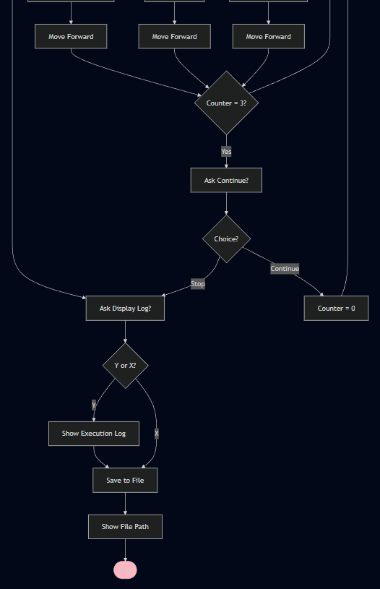
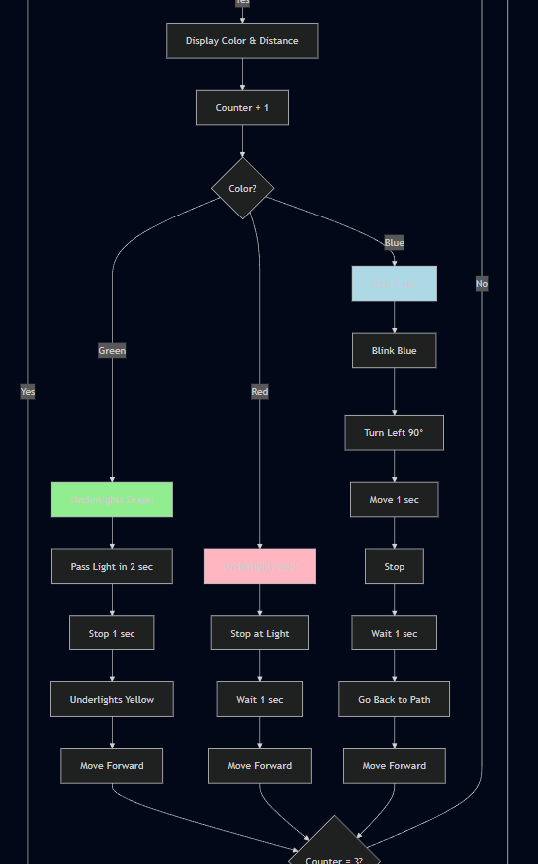
My improved algorithm design
Below, I have shown all the flowcharts I made for my task, Traffic Lights. In summary, I created one main flowchart with six subprocesses, meaning a total of seven flowcharts for this task.

